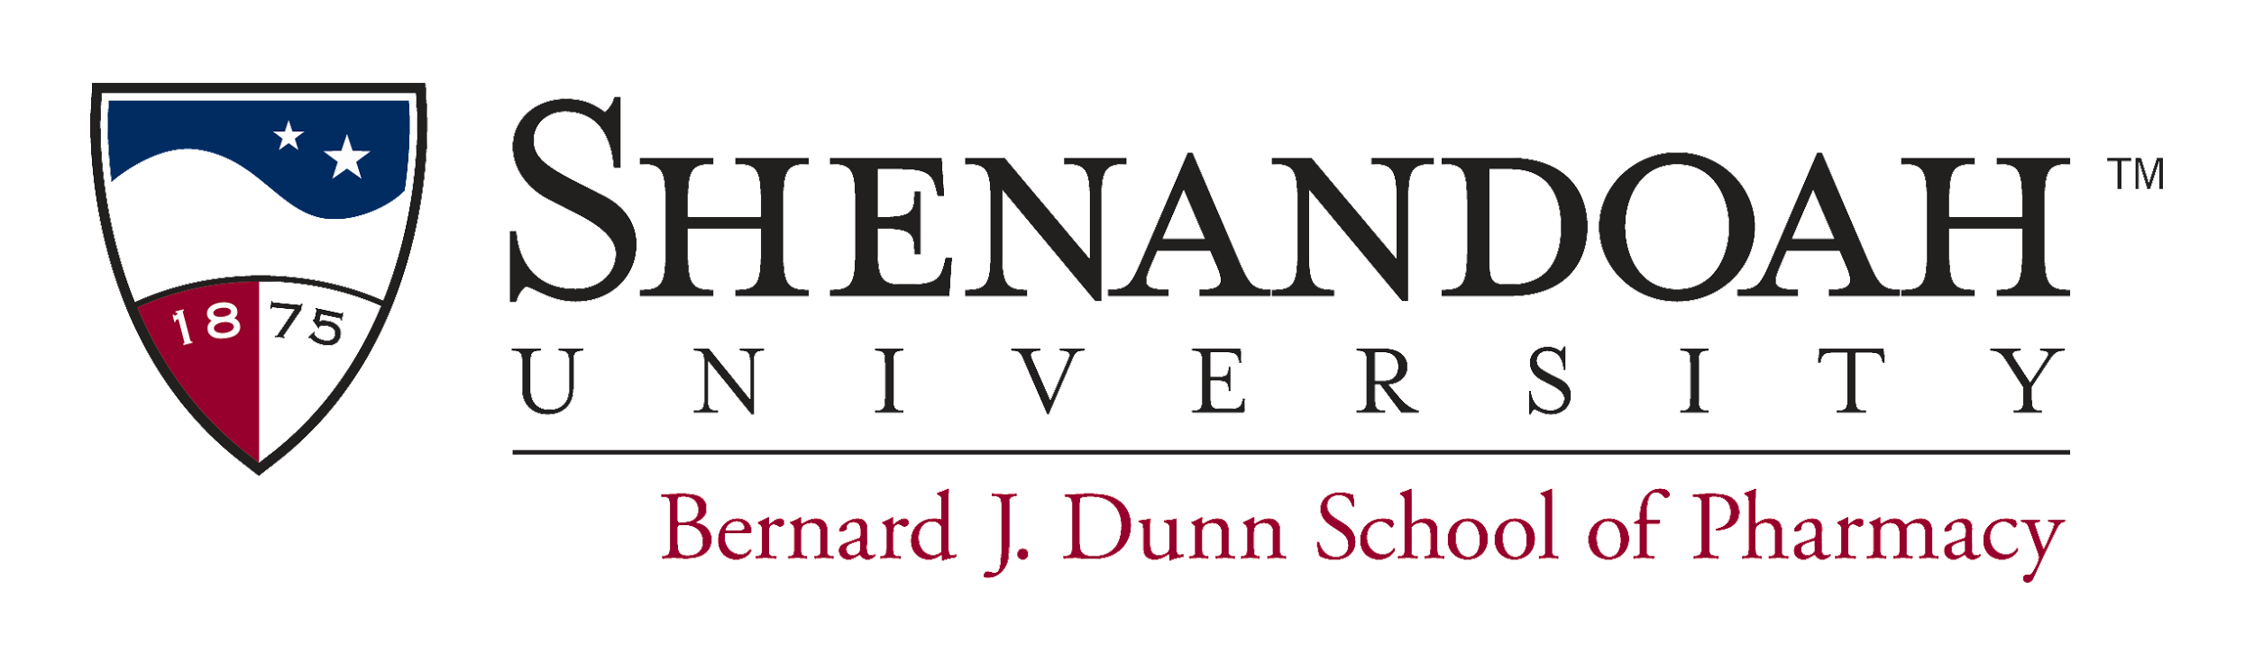  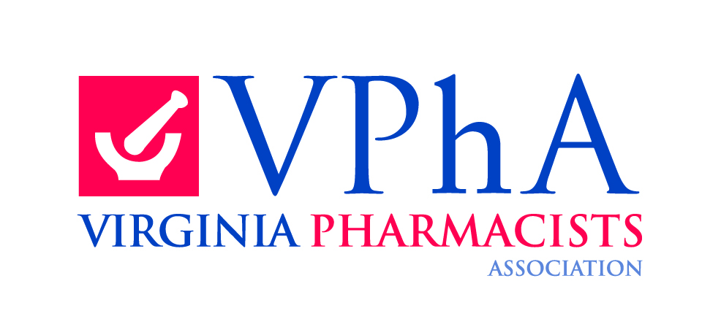 | SBIRT: “Screening, Brief Intervention, and Referral to Treatment” Training for Health Professionals  Continuing Pharmacy Education Activity
When | Sunday, March 25th, 2018 at 1:00-5:00 PM
Where | Hotel Roanoke & Conference Center  110 Shenandoah Ave, NE  Roanoke, VA 24016
Educational Goals | - To properly identify, intervene, and refer patients to treatment for substance use disorders.  - To promote the awareness of substance misuse and abuse and how these interfere with medications and contribute to comorbidities.  - To educate as to how to best communicate with patients who misuse or abuse substances to affect change.  - To equip pharmacists to incorporate SBIRT into current practice, including the training of health professions students, and to bill for services.
Learning Objectives | At the end of this activity, the pharmacist will be able to:  - Define SBIRT and understand the rationale for universal screening (Goals 1,2)  - Define at-risk and dependence levels of alcohol, prescription drug and illicit drug use (Goal 1)  - Distinguish between patients who may benefit from a brief intervention for substance misuse/abuse and those who need referral to specialized treatment (Goal 1)  - Describe how misuse and abuse may interfere with medications and cause/exacerbate comorbidities. (Goal 2)  - Define motivational interviewing and identify techniques to help patients change (Goals 1,3)  - Identify resources for referral for substance use disorders in provider’s location (Goals 1,4)  - Develop ways to incorporate SBIRT into current practice and identify ways to bill for services provided (Goal 4)  - Demonstrate how to screen for substance use disorders and provide a brief intervention for patients using motivational interviewing techniques. (Goals 1,3,4)
Faculty | Kimberly Hayashi, PharmD.
CPE Information  Target Audience  Credit Criteria  Funding Disclosure  Activity Contact  VPhA Registration/Payment  Registration | Activity Type: Application Cost:  VPhA Member Non-member  Pharmacist $75 $100  Student $40 $50  Note: Class must have a minimum of 24 participants, and a maximum of 48 participants. Register early to ensure you reserve your spot! If 24 participants are not registered 7 days in advance, the class will be cancelled and funds will be reimbursed in full.  Credit: 4 contact hours (0.4 CEU) UAN: 0101-9999-17-012-L04-P  Release Date: 07/01/2017 Expire Date: 07/01/2020  This activity is for pharmacists who want to gain knowledge in SBIRT training and practice implementation.  To receive credit the following items must be completed  - Pay for the program through www.virginiapharmacists.org  - Register for the event through supharmacy.learningexpressce.com  - Attend the entire live activity  - Complete all relevant learning assessments  - Complete an activity evaluation through supharmacy.learningexpressce.com  For those participants who have met the eligibility criteria stipulated above, participant information will be uploaded to CPE Monitor by May 25, 2018.  Training materials are funded by SAMHSA and much of the material included is based on the works of previously funded SAMHSA grantees. Virginia Pharmacists Association provided funding to complete training sessions throughout the state of Virginia.  Dr. Kimberly Hayashi  Bernard J. Dunn School of Pharmacy  1775 N. Sector Court  Winchester, VA 22601  Please pay for this program through the following link: www.virginiapharmacists.org  Online registration for Continuing Education Credit at supharmacy.learningexpressce.com  Please register by March 24, 2018 at 9:00AM.
 | The Bernard J. Dunn School of Pharmacy is accredited by the Accreditation Council for Pharmacy Education as a provider of continuing pharmacy education.

